8 BIT NUMBER IS PRIME OR NOT:

AIM: TO PERFORM A PROGRAM USING 8085 PROCESSOR

PROGRAM:

LXI H,8100H

MOV A,M

MVI C,00

MOV D,A

MOV E,A

L2: MOV B,D

L1: CMP B

JC LABEL

SUB B

JNZ L1

LABEL: CPI 00

JNZ SKIP

INR C

SKIP: MOV A,E

DCR D

JNZ L2

MOV A,C

STA 8101H

HLT

INPUT:

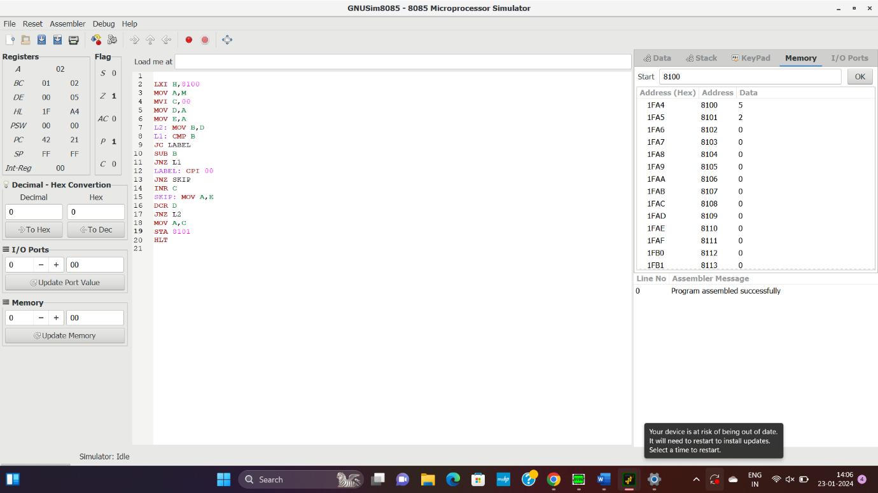

OUTPUT:



RESULT: THUS THE PROGRAM WAS EXECUTED SUCESSSFULLY.